|  |  |  |  |
| --- | --- | --- | --- |
| Test Plan Name: | PCT_WF_ DiagnosticList_Cardiology.xls |  |  |
| Solution(s): | Manual |  |  |
| Created Date: | 26-03-2015 | No. Of Steps Requiring Evidence | 3 |
| Enviroment: | Citrix | Operating System: |  |
| Associate ID: | PC | Domain: | A |
| Test Data: | N/A |  |  |

Pre-Requisites:

Actual Evidence:

|  |  |  |  |
| --- | --- | --- | --- |
| Step No: | Step 2 | Status: | Pass |
| Comments: |  |  |  |

Evidence:

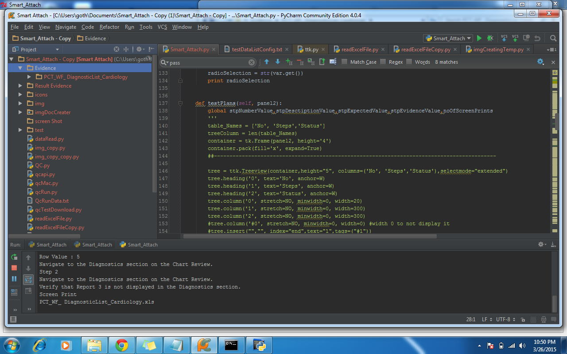

|  |  |  |  |
| --- | --- | --- | --- |
| Step No: | Step 4 | Status: | Pass |
| Comments: |  |  |  |

Evidence:

